Bob Niven
Multisport Builder, Calgary
Inducted in 2012

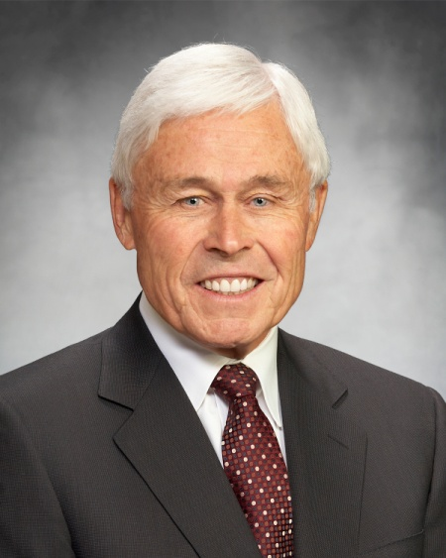

Bob Niven was the man behind the winning bid to bring the 1988 Olympic Winter Games to Calgary. For the 10 years it took to bid, plan and deliver the Games, Bob Niven played a very significant role. Bob was President of the bid committee that won the Games for Calgary in Baden Baden in 1981. He then served as Vice Chairman of the XV Olympic Winter Games Organizing Committee from 1981-1988 and was Mayor of the Olympic Village during the Games in February 1988.

During the planning phase for the Games, when it was recognized that a new organization was needed to manage and build the legacy of the Games, Bob was appointed Chairman of that organization, today known as Winsport Canada, to deliver on the mandate.

Active in both community and business affairs Bob has served as a director of many sports organizations. He is an Honorary Life Director of the Calgary Booster Club and Winsport Canada, has served as a director of the Saddledome Foundation and the Canadian Olympic Association and has three times been recognized for outstanding service to the Province of Alberta.

Bob has been an active participant in sports throughout his life, in particular skiing, golf and baseball. He furthermore has promoted the development of amateur athletes, organized competitive meets and coached junior teams. In recognition of his contribution to building the Canadian winter sports legacy Canada Olympic Park named its high performance training facility in his honour – the ‘Bob Niven Training Centre’.

