Ken Newans
Multisport Builder, Calgary
Inducted in 2011

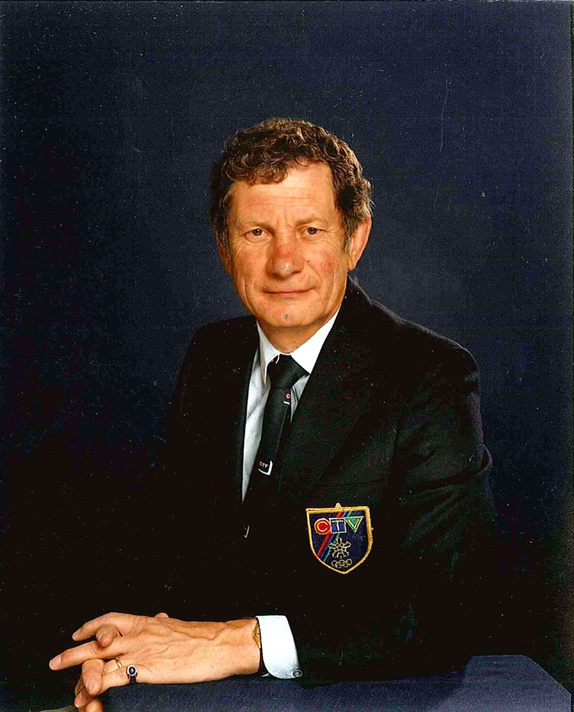

Ken Newans is an icon in Canadian Sports broadcasting. As Sports Director for CFCN TV & Radio from 1968 until his retirement in 1996, he covered countless sporting events including seven Olympic Games, five Vanier Cups and thirty Grey Cup Games. Ken Newans was also the voice of the CFL Calgary Stampeders, a CTV National Football broadcaster and feature reporter for CTV’s Wide World of Sports. His enthusiasm and commitment are apparent through his work and his involvement with the University of Calgary Athletics, numerous organizations and countless athletes as he helped raise their profile. Ken Newans has served on the Alberta Sports Hall of Fame Board of Directors for more than twenty-five years and has been inducted into the Canadian Boxing Hall of Fame, Canadian Football Reporters Hall of Fame and was admitted as a member of the Order of the University of Calgary in 2011.

Ken Newans is the only person to receive the Fred Sgambatti Award twice for his coverage of Canadian Interuniversity Sport Athletics. He received the University of Calgary’s Athletic Department Distinguished Service Award in 1992, the Peter Connellan Award for his unwavering support of Dinos Football. He was the only non-team member to be presented with a 1995 Vanier Cup Championship ring. Ken Newans has also been named to the Rural Saskatchewan Sports Hall of Fame.

